EXERCISE 2
- Write the SELECT statement to extract the ids of employees who are more than 30 years of age. Answer: SELECT emp_id FROM employee_data WHERE age > 30;
- Write the SELECT statement to extract the first and last names of all web designers.
Answer: SELECT f_name, l_name FROM employee_data WHERE title = ‘Web Designer’;
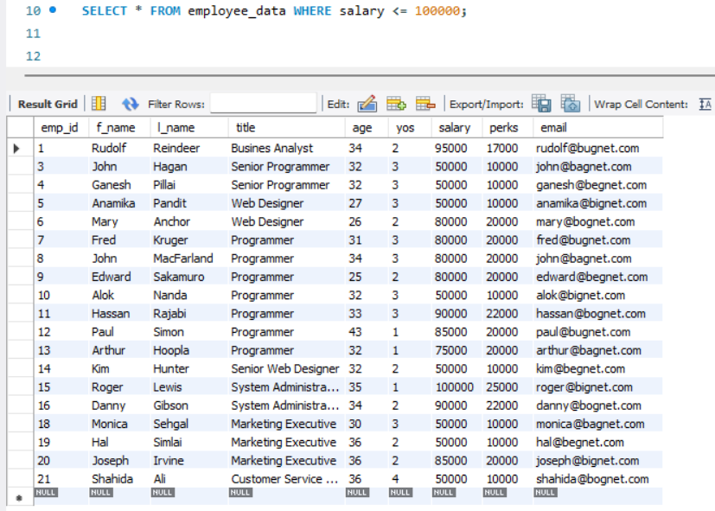
- What will the following SELECT statement display?

- How will you display the salaries and perks for employees who have more than $16000 as perks. Answer: SELECT salary, perks FROM employee_data WHERE perks > 16000;
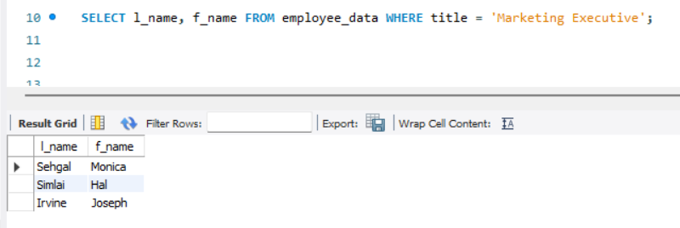
- List all employee names (last name followed by first name) who hold the title of Marketing Executive.

